Deployment & Rollback & Rollout

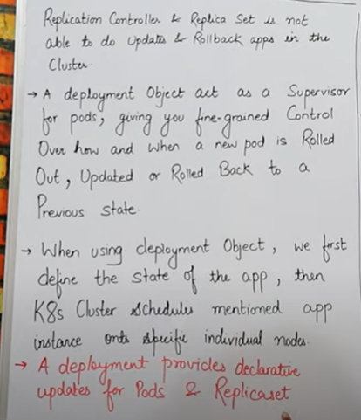

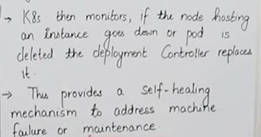

* Deployement set replica set ka upgraded version hai ,
* Replication sein hum apane app ko upgrade nahi kar sakte but deployment ki help sein hum apane app ko update kar sakte hai, rollback version kar sakte hai .
* Deployement ki help sein hum apane app ko update kar sakte hai.
* **Rolled back** matlab agar hum apane app kein previous version par jana chahahate hai aur **Rolled out** matlab mere app ka new version
* Pehale hum apane app ko jab deploy karenege toh uski eak state define karenge.
* Kubernetes is cheej ko har samaye monitor karta rahega ki jo meri node hai vo sahi sein kaam kar raha ya nahi kahi meri node down toh nahi hai, ya mere jo pod hai vo kahi delete toh nahi hogaye hai, pod agar delete hogaya hai toh phir sein humko vo kaise create karna hai
* Deployement ki help sein hum main kaan roll back aur rollout ka kaam kar sakte hai
* Yml file mein jab hum **kind:Deployement** likhenge toh kubernetes apane aap samjh jayega ki hum kis tarah ki yml file banana chah rahe toh top par deployement uske neeche yml file mein replica define hoga & then uske baad humara pod define hoga.

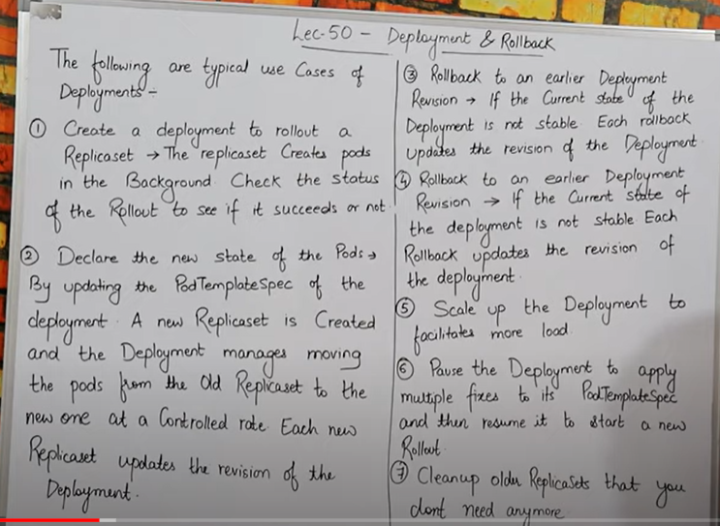

* Deployement mein tab use karunga jab mujhe kisi bhi replica kein purane version ya new version par jana ho toh hum vaha Deployement use karenge.
* Deployement set kahega Replica set ko jaake aur replica set kaam karega jo usko kaha gaya hai script mein karne kein liye , jaise ki kitane pod create huve hai kis label aur pod create karna haii kispar nahi.
* 2 nd point:- for example :- mere pass eak yml file hai jiske andar replica mene define kar rakha hai,mein chahata hu ki apane yml file ko dubara update karke usme kuch naya add karna , toh mein add kardunga aur us file ko save kar dunga, phir **kubectl apply –f yml** vali command chala denge aur vo apply ho jayega , ab baat mein yein phasati hai ki meri jo yml file pehale thii bina change kare kein pehale uske andar mene jo replica define kar rakha thaaa vo ab delete hokar naya ban gaya hoga jaise hi mene isko update kiya , but jo purani vali replica thi vo mere rollout version mein save rahegi hum chahenge toh purane version mein jaake us replica ko phir sein paa sakte hai aur uspar kaam kar sakte hai agar mene apane yml file kein andar kind:Deployement likh rakha hai toh hi mera rollout aur roll in version vala kaam karega. Purane vali replica aayegi aur id bhi change nahi hgi but humare pod purane vale jo honge vo delete ho chuke honge kyuki pod agar delete hota hai toh jab naya banta hai toh uski ip change ho jati hai .
* 5th point:-mein pod ko rollin or rollout kar sakta hu matlab pod ko ghata badha sakta hu aur, dusari baat agar mein rollout kein through apane pod delete kar raha hunga toh vo seedhe sein humare jo laest mein new pod create huve honge vo unhe delete karega , pehale .
* 6th point:- agar humare pod mein kuch problem aagayi ya bug aagaya toh hum apane deployement ko paise bhi karsakte hai jab bug fix ho jaye toh hum usko phir sein resume bhi kar sakte hai .
* 7th point :- agar mere pass koi purani replica padi hai aur mujhe ab mere purane replica ki koi bhi jarurat or need nahi hai toh us replica ko mein hardum kein liye delete bhi kar sakta hu .

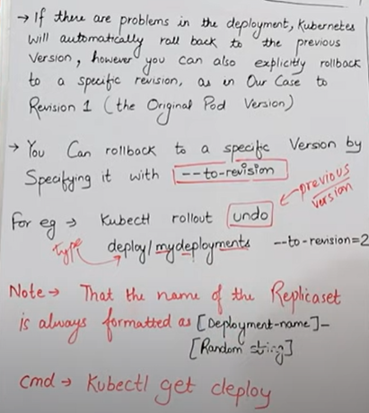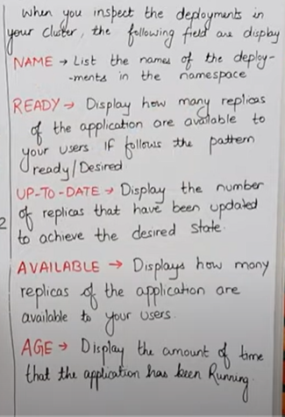

* Deployement ki help sein agar mere pass bahut saree version bane pade hai purane toh mein unme sein kisi bhi specific version par jaa sakta hu , agar mene kind: deployement likh rakha hai toh., agar specific kisi version par jana hai toh uske liye hum command use karenge **--to-revision (version name/number)**

**For e.x :-** kubectl rollout undo deploy/mydeployements --to-revision=2

Ab isme **deploy** mera **object type** hai aur **mydeployements** mera **object name** jo ki mene apane **yml file kein andar** define kar rakha hai

**Note : -** hum jo bhi apani replica set banayenge apne yml file kein andar usme jab humara replica set create hoga toh uska eak format hoga

**Format :-** [Deployement name ]-[Random string]

start hoga **[Deployement name]** sein aur end mein koi **[Random string]** laga denge hum aur humare jo pod create honge vo bhi usi hisab sei create hoge pehale deployement name then uske baad random number.

* Agar hum ye check karna chahate hai ki meri deploy proper hogayi hai ya nahi toh uske liye hum ye command use karenge. **kubectl get deploy**
* **Jaise hi hum kubectl get deploy command chalyenge humko output mein dikhega :- Name ,Ready, UP-TO-DATE, Available, Age**

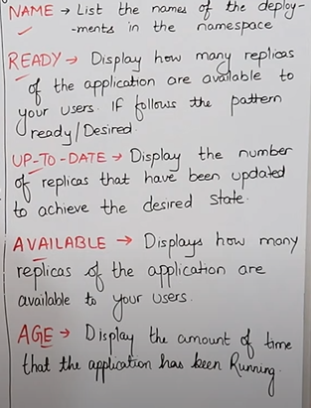

====================================================================

LAB

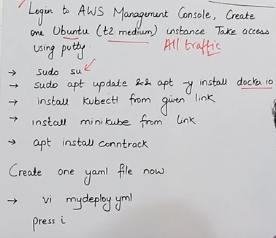

sudo su

command to install docker is

sudo apt update && apt -y install docker.io

**install Kubectl now with the given link:-**

curl -LO https://storage.googleapis.com/kubernetes-release/release/$(curl -s https://storage.googleapis.com/kubernetes-release/release/stable.txt)/bin/linux/amd64/kubectl && sudo mv ./kubectl /usr/local/bin/kubectl

install Minikube with the given link

curl -Lo minikube https://storage.googleapis.com/miniku... && chmod +x minikube && sudo mv minikube /usr/local/bin/

apt install conntrack

minikube start --vm-driver=none

minikube status

kubectl version

kubectl get nodes

* **nano mydeploy.yml**

**kind: Deployment**

**apiVersion: apps/v1**

**metadata:**

**name: mydeployments**

**spec:**

**replicas: 2**

**selector:**

**matchLabels:**

**name: deployment**

**template:**

**metadata:**

**name: testpod**

**labels:**

**name: deployment**

**spec:**

**containers:**

**- name: c00**

**image: ubuntu**

**command: ["/bin/bash", "-c", "while true; do echo Satyam-Allahabad; sleep 5; done"]**

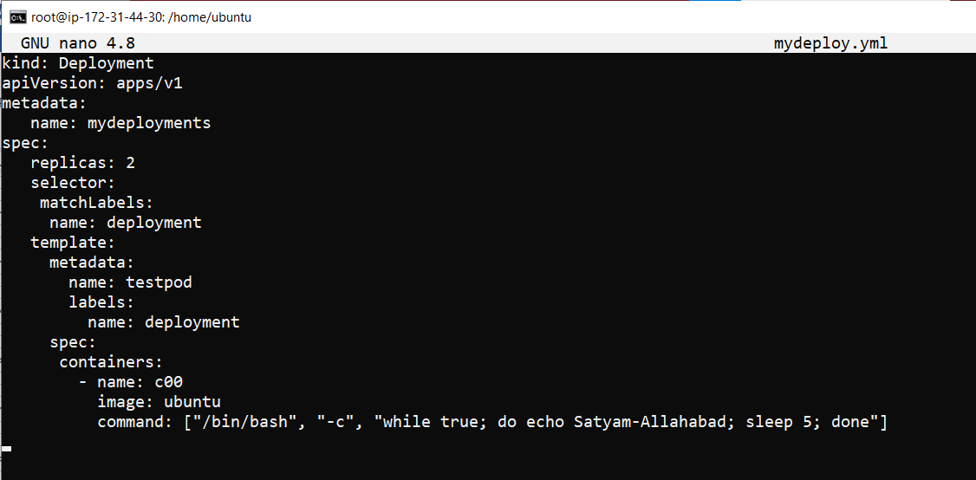

* **kubectl apply –f mydeploy.yml**

Mene jo mydeploy.yml file likha hai usko apply karne kein liye mene ye command likha hai



Iska matlab jo mera **kind:Deployement**  vala Deployement thaa uske andar mene mydeployements naam sein pod create kar diya hai .

* kubectl get pods

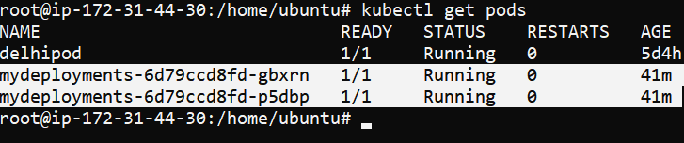

**To check deployement was created or not :-**

* **kubectl get deploy**

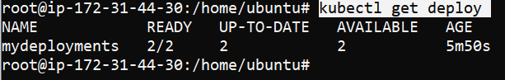

Is command ki help sein mene eak **mydeployement** naam sein eak object create kiya, aur uske andar 2pod ready hai ,2 pod updatd hai, 2 pod available hai .

**To check, how deploy create Replica & pods :-**

* **kubectl describe deploy mydeployments**

isme **deploy** mera **object type** hai aur mydeployments mera object name hai . 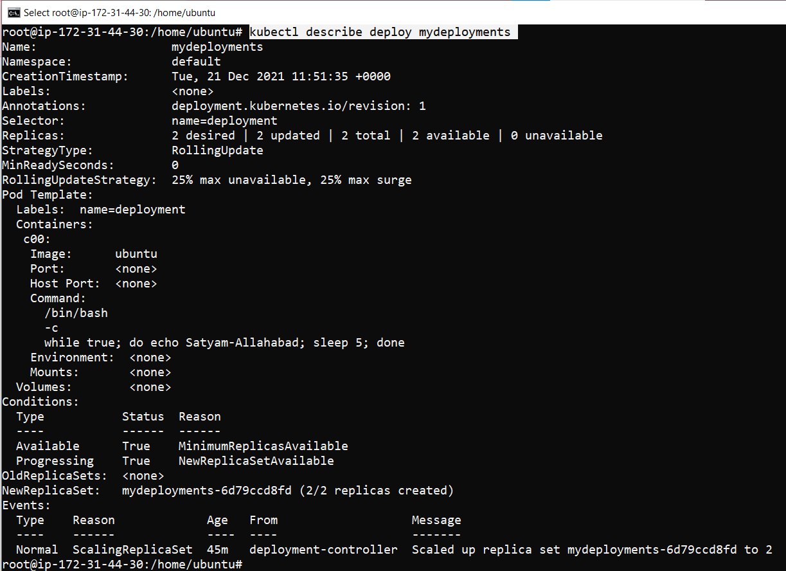

* **kubectl get rs**

isase mujhe meri **replica set** ki information millegi .

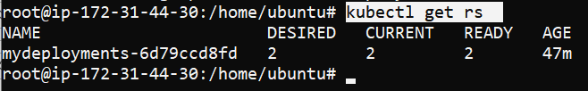

**To Scale-up or Scale-Down:-**

* **kubectl scale --replicas=1 deploy mydeployments**

iss command sein hum apane replica ko up or down kar sakte hai, aur yaha mene apani replica down kiya hai.



* kubectl get rs

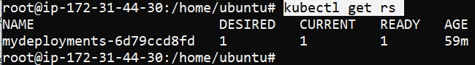

Mene apani replica 2 sein ghata kar 1 kar di

* kubectl get pods

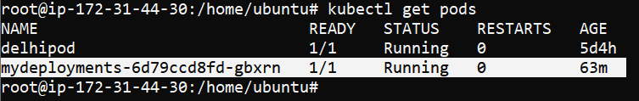

Aba mere pass kewal ek pod bacha hai.

**To check what is running inside inside container :-**

* **kubectl logs –f <podname>**
* **kubectl logs -f mydeployments-6d79ccd8fd-gbxrn**

agar mujhe apane pod kein andar jo **running container** hai unki details check karni hai toh hum ye command use karenge, isase hum apane container kein logs check kar sakte hai .

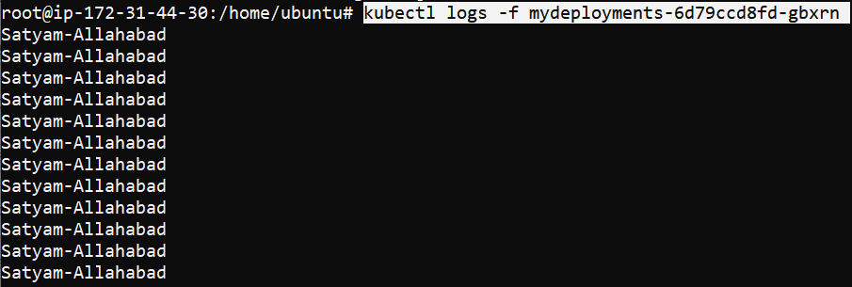

**Ctrl+z** to exit

* vi nano.yml

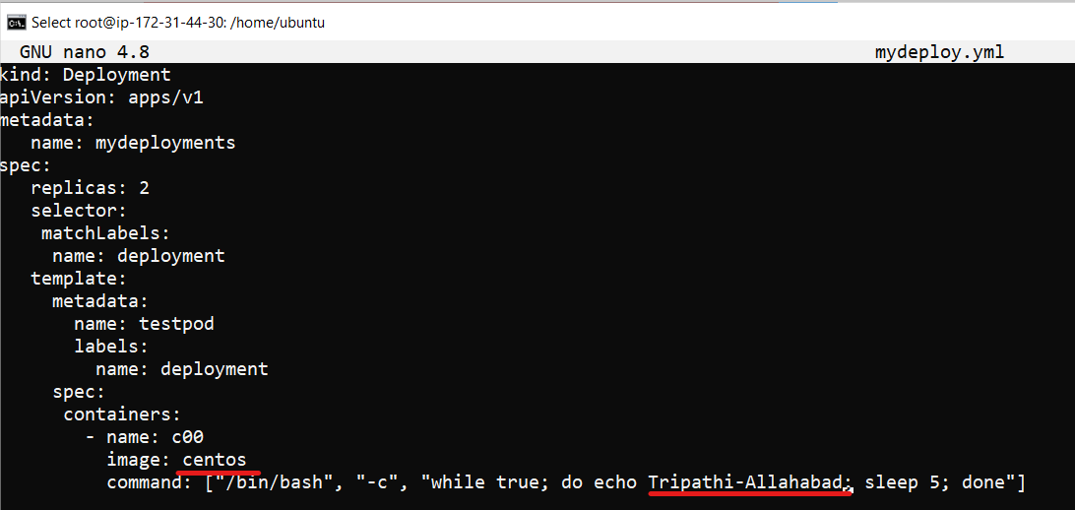

Mene change kiya thaa apane yml file kein andar, jaha mene underline kiya vahi changes kiya hai mene

* kubectl apply -f mydeploy.yml

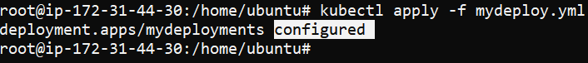

Mene jo changes kiya uske baad mene apane yml ko phir sein apply kar diya

Mene file mein jab change kiya toh vo configured hog aye vo sab

* **kubectl get rs**

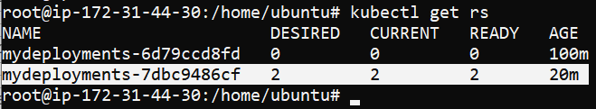

Hum dekh sakte hai jisko headline diya hai mene pic mein vo mera new deployement hai jiske andar 2 pod desired running aur current bata raha.

Hum ye bhi dekh sakte hai jo mere purana deploy thaa vo ab 0 ho gaya hai hum jitani baar apane yml ko baar baar update karenge ye utani baar naya version create kar dega , mere purane version mein ab eak bhi pod nahi bachee.

Basically dekha jaye toh puri nayi replica set hi create huyi hai .

* kubectl get pods

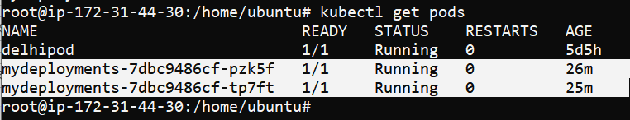

Hum agar match kare toh humare update karane kein baad yml humari nayi ban gayi aur humare pod bhi naye bane hai agar hum pod ki id match kare naye aur purane vale yml mein toh different millenge.

Eak baat aur humari jo purani replica thaa usme scale out kiye thee usme mene 2 ki jagah 1 kar diya thaa but mene yml kein andar change nahi kiya isliye jaise mene dubara yml ko apply kiya toh jo replica humare yml mein define hai utani ban gayi .

* kubectl logs -f mydeployments-7dbc9486cf-tp7ft

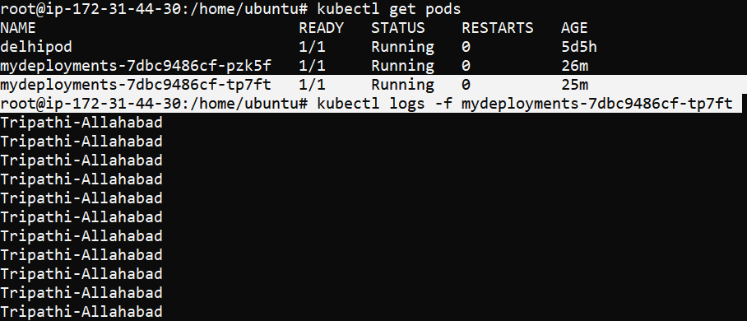

Hum dekh sakte hai humane jo new yml mein update kiye thee vo logs mujhe ab dikh rahe jaise hi mene pod ka name dala toh.

* kubectl exec mydeployments-7dbc9486cf-tp7ft -- cat /etc/os-release

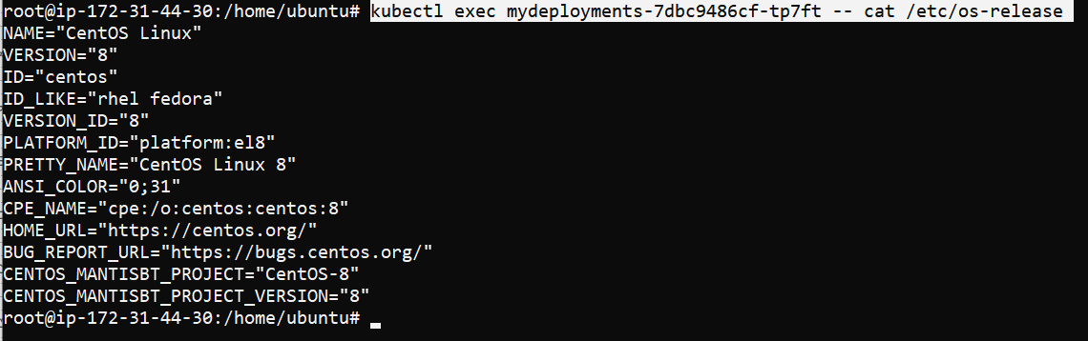

Agar hum dekhe toh mene apane yml file kein andar Ubuntu ki jagah centos kar diya aur jab mene ye command chalayi toh mujhe dikh raha mera machine kein operating system change hogaya .ab mera machine centos operating system par chal raha pehale Ubuntu par thaa.

**To check your current rollout status:-**

* kubectl rollout status deployment mydeployments

hum iss command sein apane rollout ki current status dekh sakte hai .



hum jis bhi version par baithe honge jaise ye command chalayenge turant eak pichale version par chale jayenge hum .

**To check your rollout history :-**

* kubectl rollout history deployment mydeployments

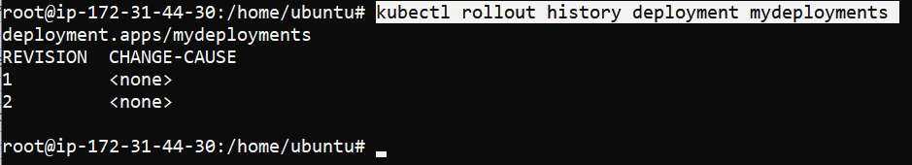

hum iss command sein rollout ki history check kar sakte hai , kitani baar mene files ko update kiya hai aur kitani baar files mein changes kiya hai vo hum sab cheej dekh sakte hai.humare pass kitane versions hai vo bhi pata chal jayega

isme 1 st vala mera jab mene pehali baar yml chalayi thii vo hai aur 2 nd vala jab mene apani yml dusari baar update karne kein baad chalaya vo vala show kar raha.

**To go to the previous version :-**

* kubectl rollout undo deploy/mydeployments

is command sein hum present mein jis version par hai usase eak pechale version par jaa sakte hai, isliye undo lagaya hai aur agar specific kisi version par mujhe jana hai toh uske liye hum dusari command use karenge jo mene previously notes mein likh rakhi hai .

Humare previous version mein aane sein pehale humare pass jitane pod thee utane hi pod rahenge humare pass previous version mein jaane kein baad bhi bas un pod kaversion change ho jayega

For e.x =

Agar mere current version mein 4 pod hai aur mere previously version mein pehale 10 pod thee but abhi current mein mere pass 4 pod hai aur mein chahata hu ki mein current version sein previously version mein jau toh mere previously version mein bhi bas kewal 4 pod hi dikhenge bas us pod kein version change hojayenge .



* kubectl get deploy

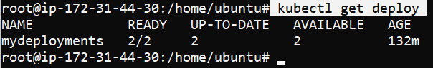

* kubectl get pods

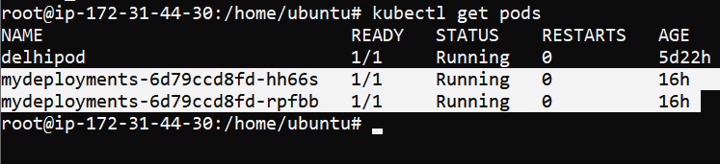

* kubectl exec mydeployments-6d79ccd8fd-rpfbb -- cat /etc/os-release

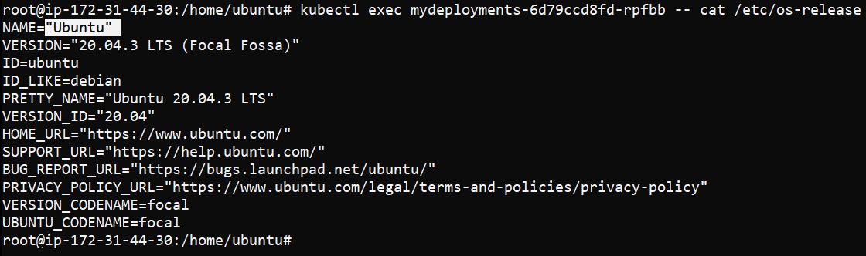

Ab mein dekh sakta hu jab mene undo command chalaya toh mein previous version mein aagaya phir sein apane aur kuch dair pehale mene upar Ubuntu ki jagah centos kiya thaa apane image kein andar but ab phir sein mene previous par aagaya to hiss wajah ein mere Ubuntu operating system phir sein chalne laga.

=============================================================================

**Failed Deployement**

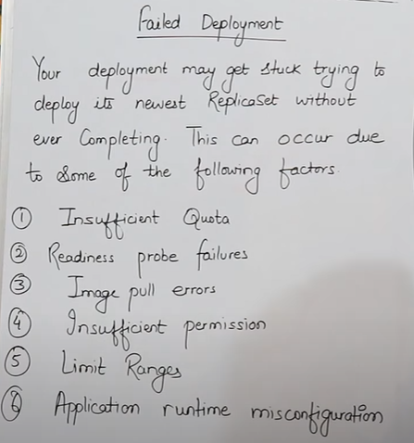

* **kuch reasons hai jiski wajah sein humare deployement fail ho jate hai .**
* **Insufficient quota** = matlab humane jo node liye kya pata uske anadr sufficient space nah o iss wajah sein bh mera deployement fail ho sakta hai.
* **Readiness probe failures** = Agar mene kisi tareeke ka deployement kiya aur us samaye meri node working mein na ho ya node ready na ho uski wajah sein bhi humara deployement fail ho sakta hai
* **Image pull errors** = kabhi-kabhi jab hum yml file kein andar apani image ko pull karne kein liye likhate hai image ka naam aur image ka address galat ho jata hai jiski wajah sein bhi humara deployement fail ho jata hai
* **Insufficient permission** = Kabhi kabhi hum aise image lekar aate hai jiski humein permission hi na ho uski wajah sein bhi humari deployement fail ho sakti hai
* **Limit Ranges** = kisi ki agar limit humane jada agar exceed kar di ho toh uske wajah sein bhi humara deployement fail ho sakta hai .
* **Application runtime misconfiguration** = agar humari application kisi wajah sein nahi chal payi toh uski wajah sein bhi mera deployement fail ho jata hai .